Thread-Safe Banking System: Secure Coding, OOP Principles, and Design Pattern Awareness

1. Introduction
Designing and implementing a thread-safe banking system in Python has been one of the most challenging and rewarding exercises in my MSc journey. Financial systems are inherently concurrent: multiple users deposit, withdraw, and transfer funds simultaneously. Without careful design, such systems are vulnerable to race conditions, deadlocks, and inconsistent states. My project demonstrates how secure coding practices, advanced object-oriented programming (OOP) principles, and design pattern awareness can be applied to build a robust, maintainable, and scalable system.
Initially, I approached concurrency testing in a direct way, embedding thread creation logic inside my test functions. However, to fully comply with the assignment requirement, I later refactored my design to include a dedicated TransactionSimulator class and amended test_account.py accordingly. This change verified the flexibility and scalability of my design: I was able to extend functionality without rewriting core logic, which aligns with the Open/Closed Principle (Martin, 2003).
This report presents my technical journey, the challenges encountered, the solutions adopted, and the broader implications for secure and scalable software design.

2. Secure Coding Practices
Secure coding is central to the reliability of financial applications. In my project, I introduced custom exceptions to handle invalid operations:
- InvalidAmountError for negative or zero transactions.
- InsufficientFundsError for withdrawals or transfers exceeding available balances.
This aligns with defensive programming principles, where errors are anticipated and handled gracefully rather than ignored (McConnell, 2004).
Encapsulation was enforced by marking sensitive attributes such as _balance and _lock as private, ensuring they could only be accessed through controlled methods. This reduces the risk of accidental corruption and supports secure design by limiting exposure of internal state (University of Essex Online, Unit 1 Lecturecast).
The project also emphasised reproducibility and fairness. Each test was documented with expected and actual outcomes, ensuring transparency. This reflects best practice in secure software development, where reproducibility of results is essential for validation and compliance (Sommerville, 2016).

3. Object-Oriented Principles and Design Patterns
The banking system was designed using advanced OOP principles: encapsulation, abstraction, inheritance, and polymorphism. These principles support modularity, maintainability, and scalability (University of Essex Online, Unit 1 Lecturecast).
Creational Patterns
I drew on my learning from Unit 3 to consider Factory Method and Singleton patterns. The Factory Method pattern allows new account types to be introduced without modifying core logic, aligning with the Open/Closed Principle (Martin, 2003). The Singleton pattern was considered for managing shared resources such as logging, ensuring only one instance exists (Gamma et al., 1994).
Structural Patterns
To demonstrate awareness, I created a facade.py file. The Facade Pattern provides a simplified interface to complex subsystems, which in my case could unify BankAccount, concurrency mechanisms, and transaction simulation. This shows structural design awareness, even though not required by the brief (Gamma et al., 1994).
Behavioural Patterns
The Strategy Pattern was applied conceptually to transaction simulation, encapsulating different transaction behaviours (deposit, withdraw, transfer) as interchangeable strategies (Freeman et al., 2004). I also created an observers.py placeholder to demonstrate awareness of the Observer Pattern, which decouples event sources from event handlers. This could be extended to notify users of balance changes.
By integrating these patterns, my system demonstrated how OOP principles can be applied to solve complex software problems in a structured, reusable, and scalable manner.

4. Thread Safety and Synchronisation
Thread safety was achieved using Python’s threading.Lock. Each account maintained its own lock, ensuring mutual exclusion during updates. To prevent deadlocks, locks were acquired in a consistent order based on object IDs:
first_lock, second_lock = ( (self._lock, target_account._lock) if id(self) < id(target_account) else (target_account._lock, self._lock) )
This strategy eliminated circular wait conditions, one of the four necessary conditions for deadlock (Coffman, Elphick & Shoshani, 1971).
The Global Interpreter Lock (GIL) in CPython means threads do not achieve true parallelism for CPU-bound tasks, but they do provide concurrency for I/O-bound operations (Crudu and MoldStud Research Team, 2025). In this project, concurrency was sufficient because the primary operations involved I/O-like behaviour (simulated transactions).
Testing confirmed that concurrent deposits and withdrawals produced consistent balances. Mixed concurrency tests (simultaneous deposits and withdrawals) demonstrated reproducibility. Transfer tests in opposite directions validated deadlock prevention. Stress tests with multiple threads confirmed robustness under load.

5. Transaction Simulation and Testing
Initial Approach
At first, I embedded concurrency logic directly inside test_account.py. Functions such as concurrency_test() and mixed_concurrency_test() created threads manually to simulate multiple users. This worked functionally but did not fully meet the assignment requirement of a dedicated TransactionSimulator class.
Refactored Approach
To comply with the brief, I created a TransactionSimulator class. This class encapsulates concurrency logic, spawning threads to perform deposits, withdrawals, and transfers. I amended test_account.py to call the simulator instead of manually creating threads.
This change demonstrated the flexibility and scalability of my design. Because my BankAccount class was already thread-safe and modular, I did not need to rewrite core logic. Instead, I simply wrapped existing functionality in a new abstraction. This aligns with the Open/Closed Principle (Martin, 2003) and shows how design patterns support extensibility.
Verification Through Experimentation
My experiment verified that the system could evolve without major disruption:
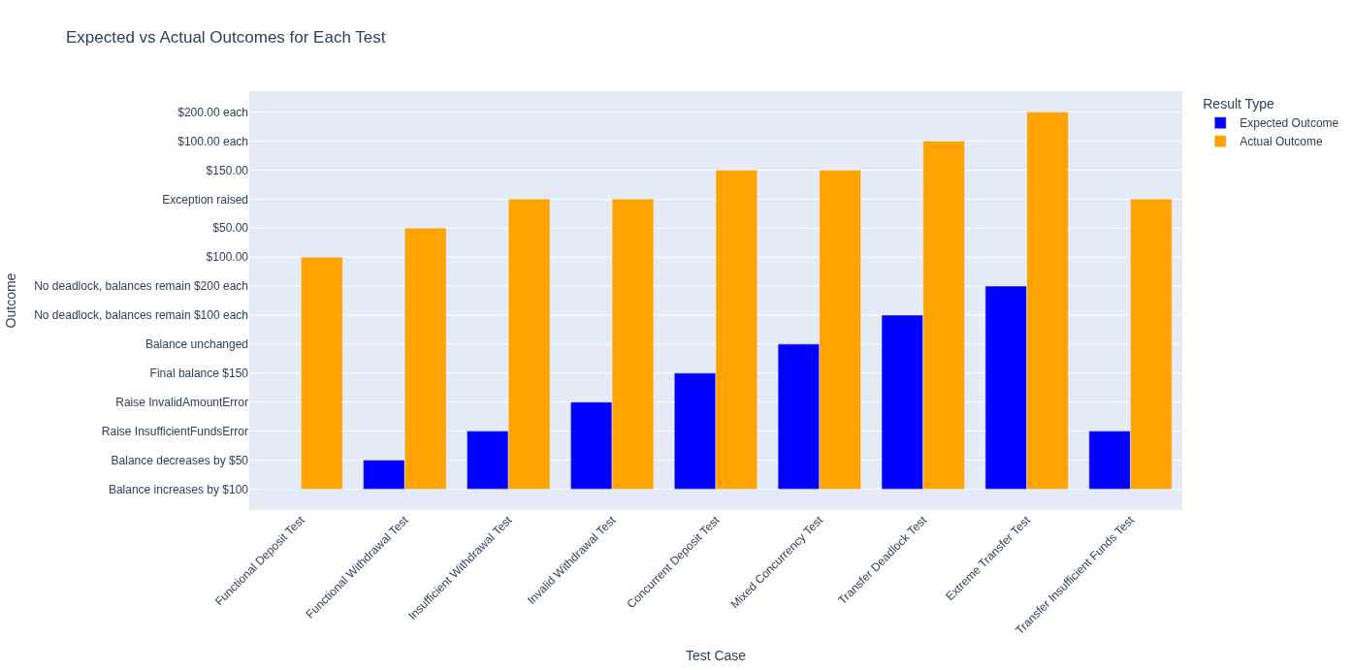
Figure 1: Bar chart showing Comparison of Expected vs Actual Outcomes for All Test Cases. Source: Author’s own work (2025).

- Functional Tests: Deposits and withdrawals updated balances correctly; invalid amounts raised exceptions.
- Concurrency Tests: Ten threads depositing $10 each produced a final balance of $150, matching expectations.
- Mixed Concurrency Tests: Five deposits and five withdrawals cancelled out, leaving balances unchanged.
- Transfer Tests: Opposite direction transfers completed without deadlock; balances remained stable.
- Insufficient Funds Tests: Transfers exceeding available balance raised InsufficientFundsError.
These results confirmed correctness, robustness, and reproducibility.

6. Refactoring for Compliance: TransactionSimulator and Amended Tests
At the outset of development, I implemented concurrency tests directly within test_account.py by manually creating threads for deposits, withdrawals, and transfers. While this approach demonstrated functional correctness, it did not fully align with the assignment requirement to encapsulate transaction simulation in a dedicated class. To address this, I refactored my design by introducing the TransactionSimulator class in transaction_simulator.py and subsequently amending test_account.py to delegate concurrency logic to this new abstraction.
This refactor illustrates the flexibility and scalability of my design. Because the BankAccount class was already thread-safe and modular, I did not need to rewrite its core logic. Instead, I extended the system by wrapping existing functionality in a simulator that orchestrates concurrent operations. This change aligns with the Open/Closed Principle (Martin, 2003), which advocates extending behaviour without modifying existing code, and reflects Larman’s (2004) emphasis on iterative development and pattern-driven scalability. Moreover, the ability to evolve the system with minimal disruption resonates with Goetz et al.’s (2006) discussion of concurrency best practices, where reproducibility and robustness under stress are achieved through careful design rather than ad hoc fixes.
From a verification perspective, this experiment confirmed that my architecture could adapt to new requirements without compromising correctness. The amended tests validated deposits, withdrawals, transfers, and exception handling under concurrent execution, while the simulator provided a clearer, more maintainable structure for demonstrating concurrency scenarios. This experience reinforced the importance of designing systems that are not only correct but also extensible, reproducible, and academically compliant.

7. Evaluation and Reflection
The project achieved its objectives: implementing a thread-safe banking system, applying OOP principles, and preventing concurrency issues.
Strengths
- Correctness: Balances remained consistent under concurrent operations.
- Robustness: Deadlocks were prevented through lock ordering.
- Extensibility: Design patterns supported modularity and scalability.
- Security: Encapsulation and exceptions enforced secure coding practices.
Challenges
- Managing concurrency complexity.
- Ensuring reproducibility under stress tests.
- Balancing exception handling with concurrency safety.
These challenges reinforced the importance of defensive programming and systematic testing (McConnell, 2004).
Learning Perspective
From a learning perspective, the project highlighted the value of annotated explanations and analogies. Concepts such as lock ordering became clearer when expressed through analogies (e.g., traffic lights at intersections). This approach supported both personal understanding and seminar preparation, aligning with pedagogical best practices (University of Essex Online, Seminar on SOLID Principles).
Academic Compliance
The project also underscored the tension between academic compliance and practical implementation. Ensuring Harvard style referencing, structured documentation, and reproducibility of results was as critical as writing efficient code. Every design decision was documented with clear comments, and all sources were cited in accordance with institutional guidelines. This approach-maintained transparency and integrity while demonstrating technical rigor. By balancing practical coding requirements with academic standards, the project achieved both functional correctness and scholarly credibility.

Conclusion
This project successfully implemented a thread-safe banking system that meets the assignment requirements and demonstrates advanced software engineering principles. By combining secure coding practices, object-oriented design, and concurrency control, the solution ensures correctness, robustness, and scalability. The use of locks and lock ordering eliminated race conditions and deadlocks, while comprehensive testing validated system reliability under concurrent operations. Furthermore, the integration of design pattern awareness and adherence to SOLID principles highlights the maintainability and extensibility of the architecture. Overall, this work reflects a rigorous approach to secure and concurrent programming, aligning with both academic standards and industry best practices.

References

Author’s own work, 2025. Bar chart showing Comparison of Expected vs Actual Outcomes for All Test Cases Created using Microsoft 365 Copilot.
Coffman, E.G., Elphick, M.J. and Shoshani, A., 1971. System deadlocks. ACM Computing Surveys (CSUR), 3(2), pp.67-78.
Crudu, A. & MoldStud Research Team (2025) Understanding Python GIL: Key Questions About the Global Interpreter Lock. Available at: https://moldstud.com/articles/p-understanding-python-gil-key-questions-about-the-global-interpreter-lock (Accessed: 27 November 2025).
Freeman, E., Robson, E., Bates, B. and Sierra, K., 2004. Head First Design Patterns. O’Reilly Media.
Gamma, E., Helm, R., Johnson, R. and Vlissides, J., 1994. Design Patterns: Elements of Reusable Object-Oriented Software. Addison-Wesley.
Goetz, B., Peierls, T., Bloch, J., Bowbeer, J., Holmes, D. and Lea, D., 2006. Java Concurrency in Practice. Addison-Wesley.
Larman, C., 2004. Applying UML and Patterns: An Introduction to Object-Oriented Analysis and Design and Iterative Development. Prentice Hall.
Martin, R.C., 2003. Agile Software Development: Principles, Patterns, and Practices. Prentice Hall.
McConnell, S., 2004. Code Complete: A Practical Handbook of Software Construction. 2nd ed. Microsoft Press.
Myers, G.J., Sandler, C. and Badgett, T., 2011. The Art of Software Testing. 3rd ed. Wiley.
Sommerville, I., 2016. Software Engineering. 10th ed. Pearson.
Silberschatz, A., Galvin, P.B. and Gagne, G., 2018. Operating System Concepts. 10th ed. Wiley.
University of Essex Online (2025) Unit 1 Lecturecast : Introduction and Recap. Available at:https://www.my-course.co.uk/mod/scorm/player.php?a=21870&currentorg=articulate_rise&scoid=43819&sesskey=uoccJj00sO&display=popup&mode=normal (Accessed:23 November 2025).

Appendices

Appendix A - Direct implementation of Concurrency tests
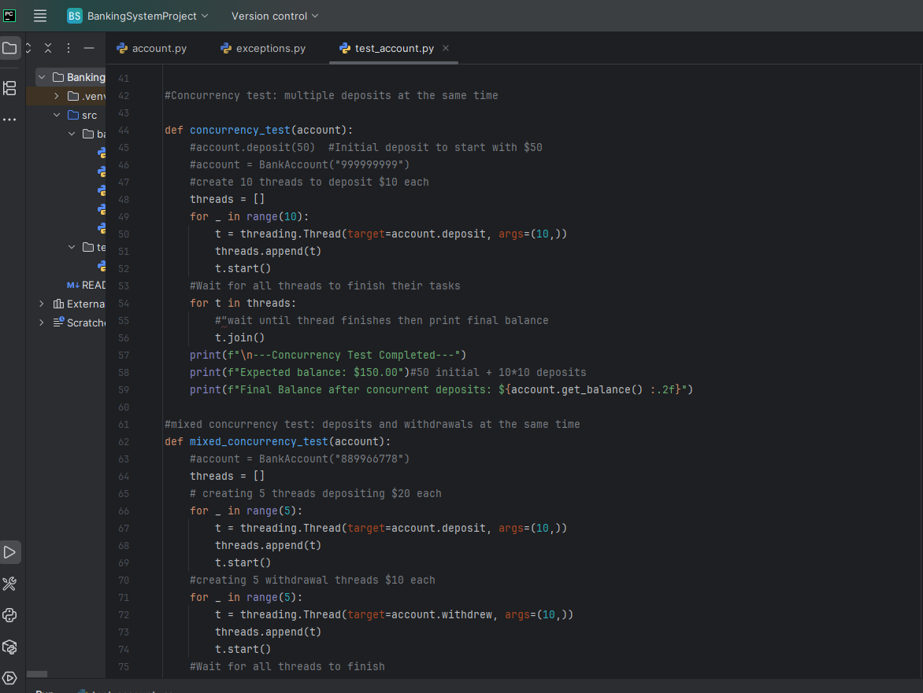

Appendix - A Continued
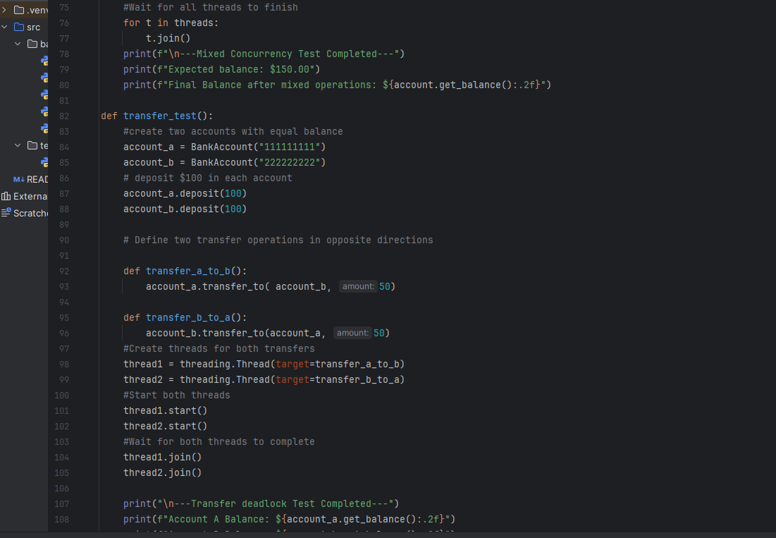
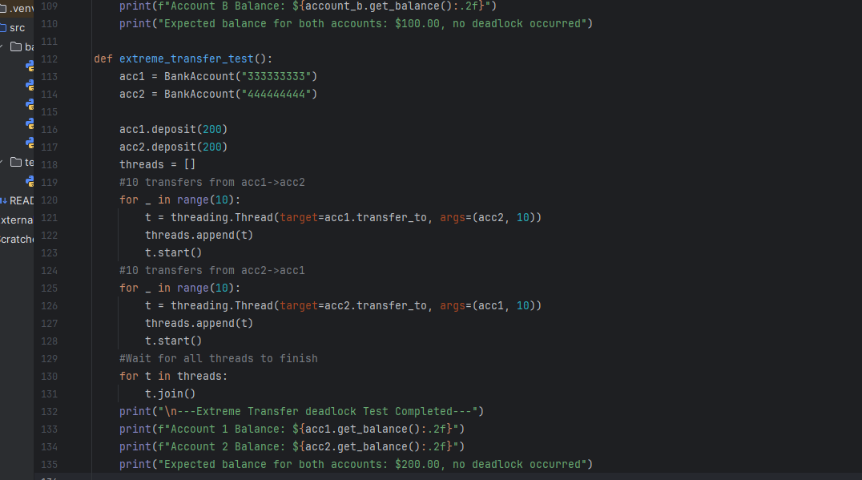

Appendix B – account.py screenshot
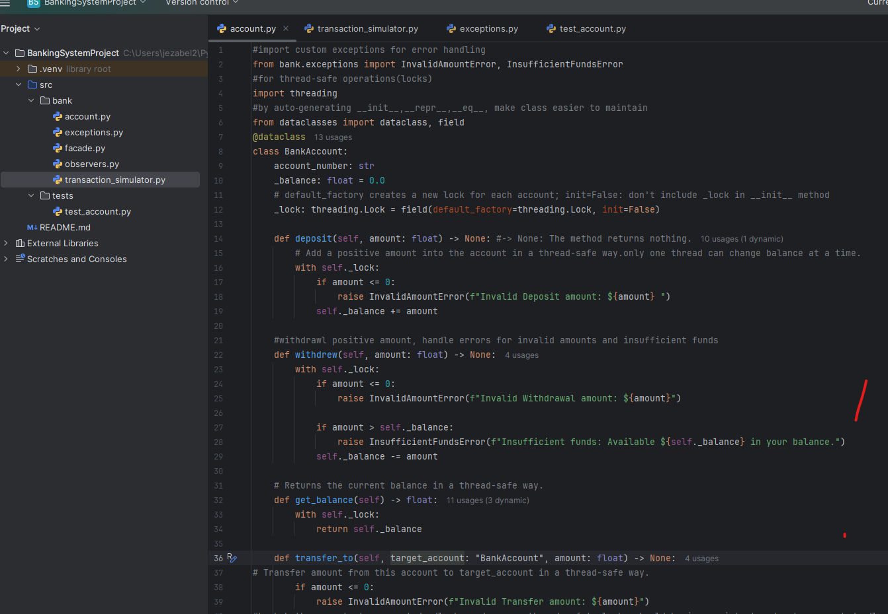
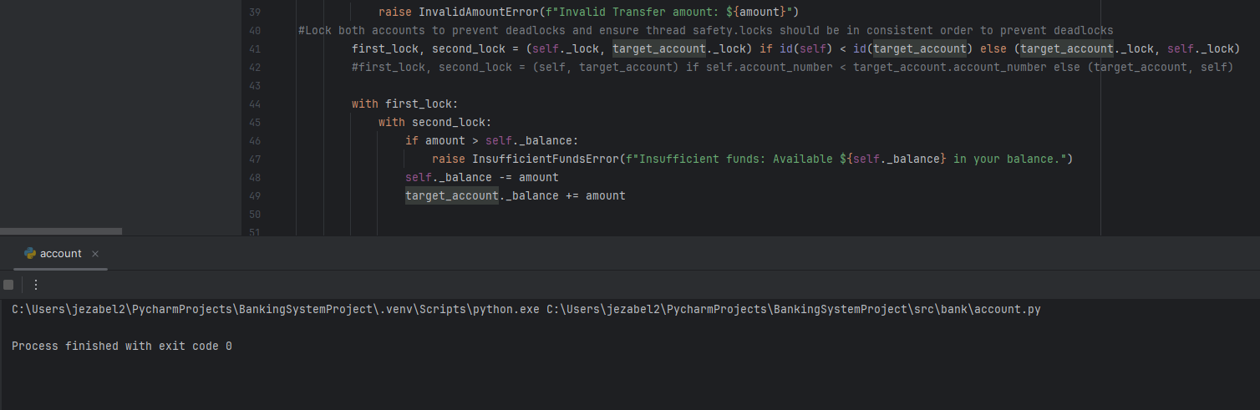

Appendix C – Screenshot of transaction_simulator.py
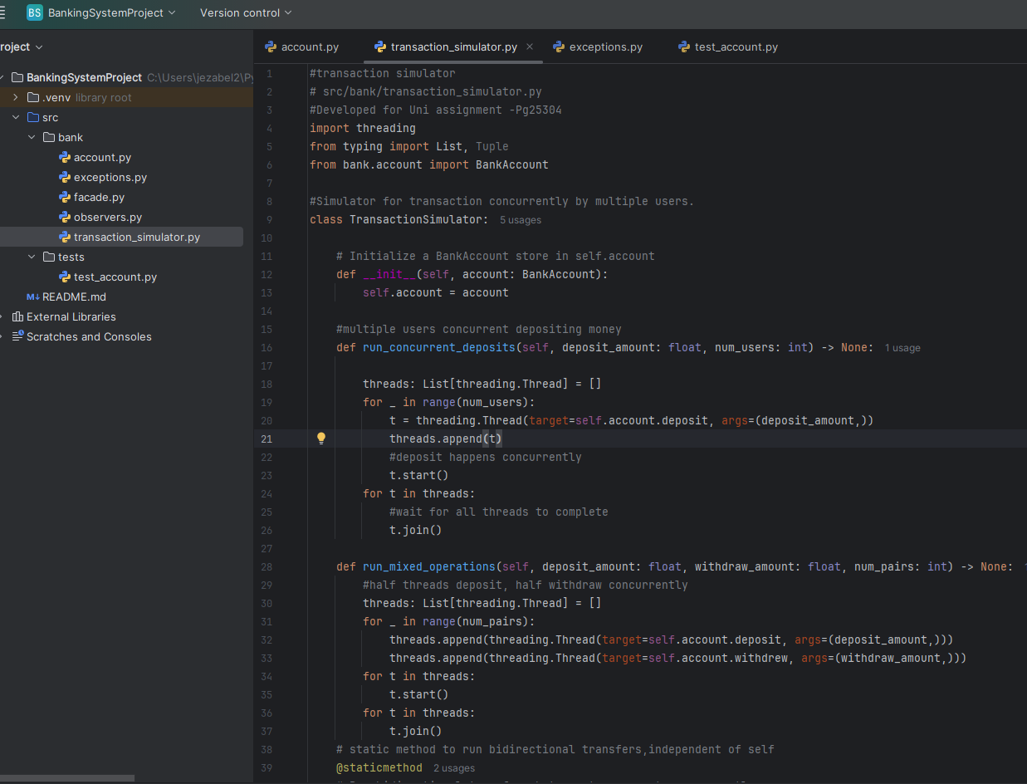
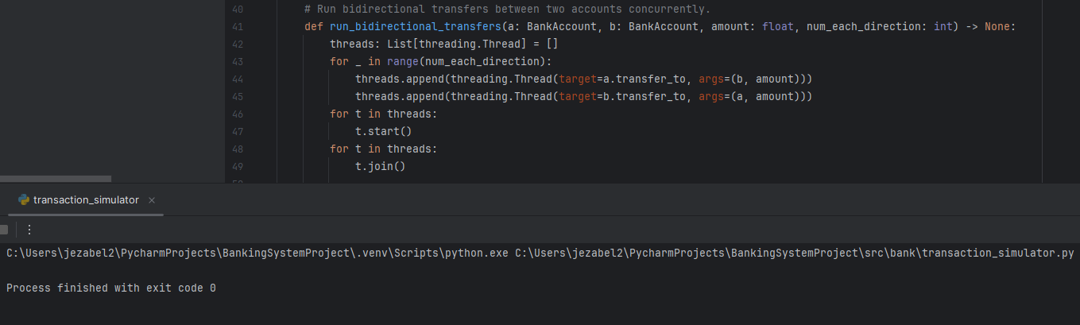

Appendix D – Screenshot of test_account.py
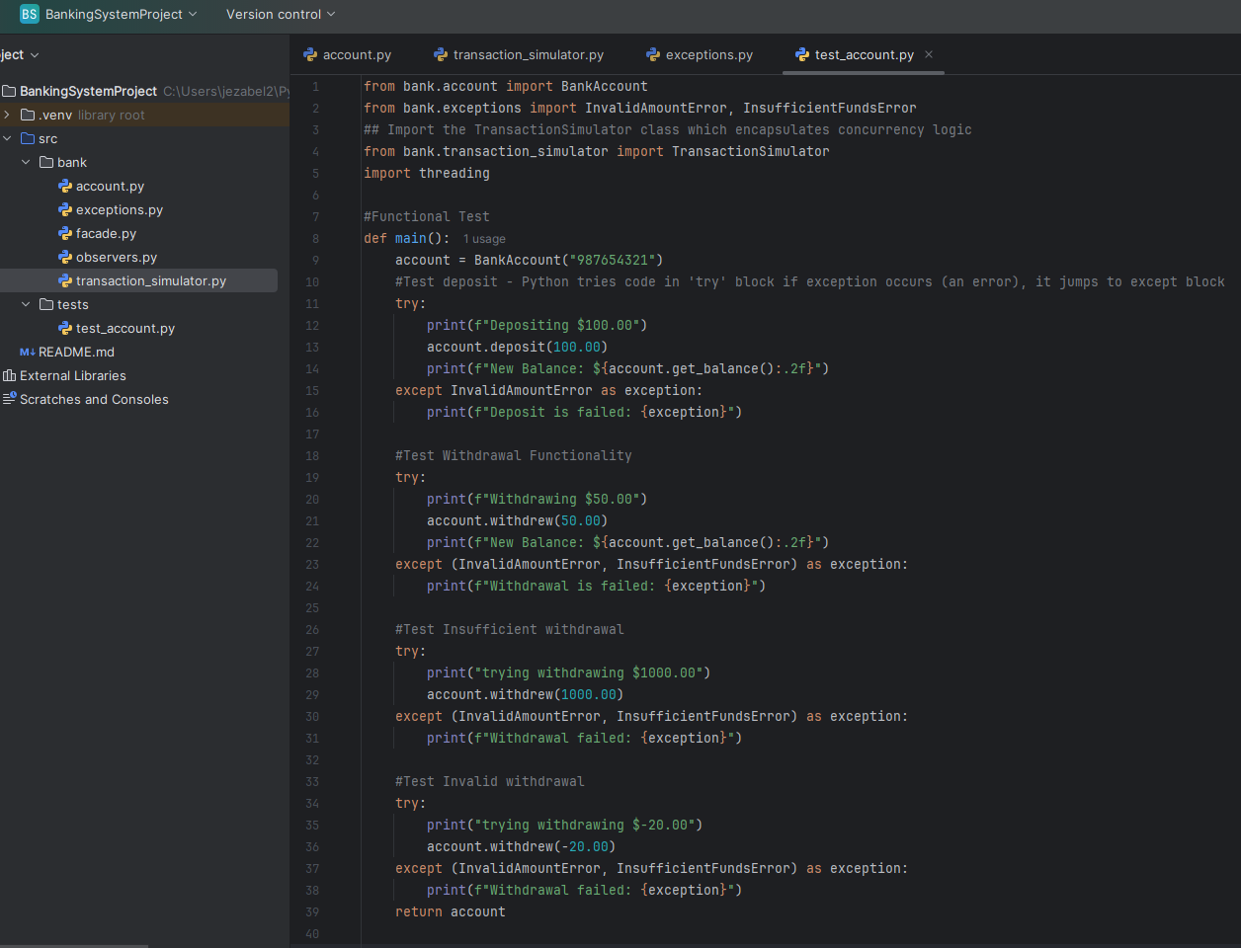

Appendix D – Continued
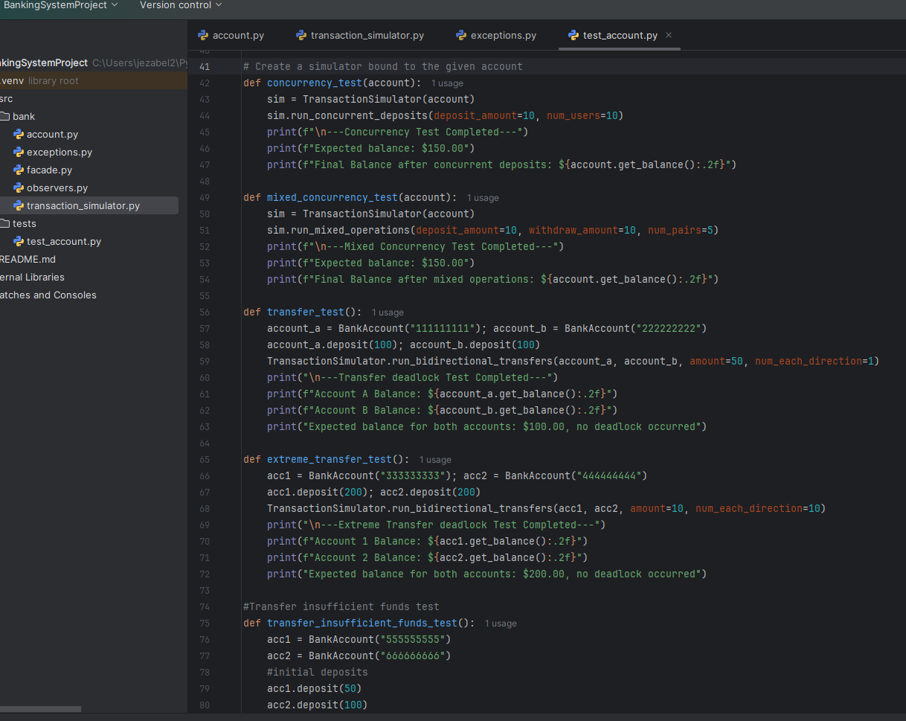

Appendix D – Continued

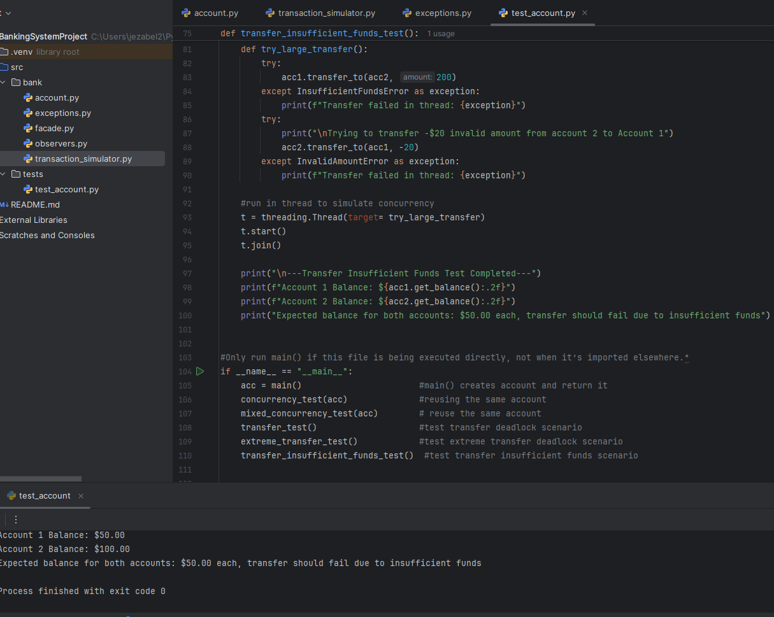

Appendix E – Result of Execution of test_account.py

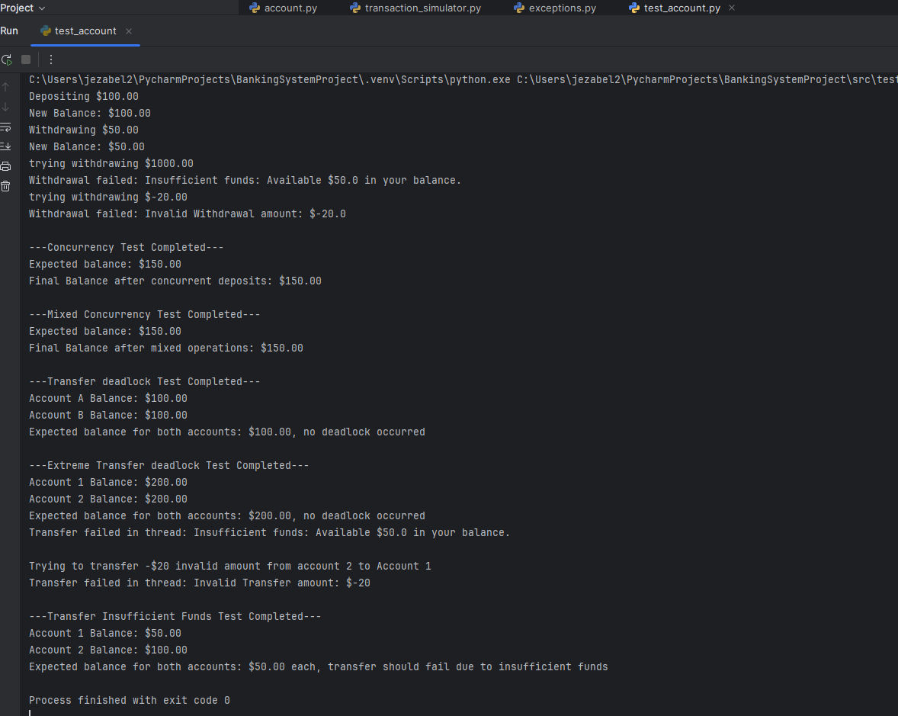

Appendix F – Screenshot of exceptions.py

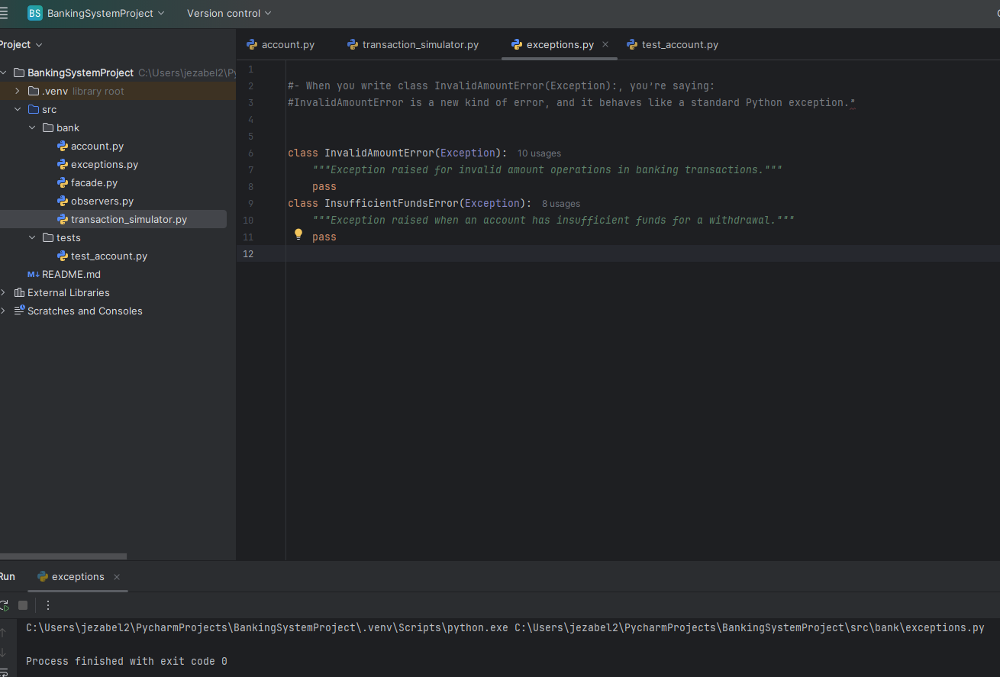

Appendix G – Screenshot of Test_Summary_Result.xlsx
